**Assignment (MICROSOFT WORD)**

**Date Representation through Tables and Images**

Instructor **Sir Farhan Ali Shah**

Prepared by Muhammad Jaffar

|  |  |  |
| --- | --- | --- |
| **Item** | **Discerption** | **Price** |
| **Apple** | **Fresh Red Apple** | **$1.00** |
| **Banana** | **Ripe banana** | **$0.50** |
| **mango** | **Sweet mango** | **$1.00** |
| **Orange** | **Juicy orange** | **$0.85** |

**Fruit Desecrations**

1. **Apple**

• Description: Apples are nutritious fruits, high in fiber and vitamin C. They are often enjoyed fresh, in salads, or as juice.

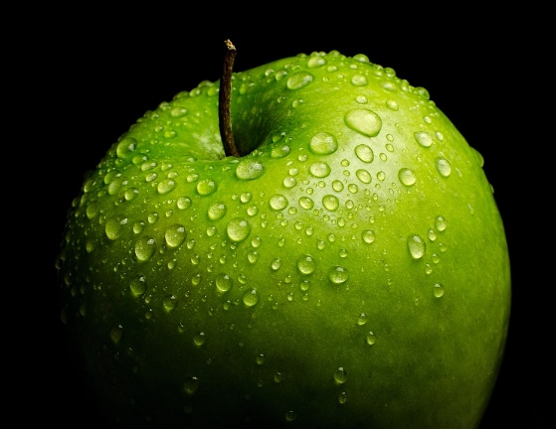

1. **Banana**

• Description: Bananas are an excellent source of potassium and energy. They make for a quick and healthy snack.

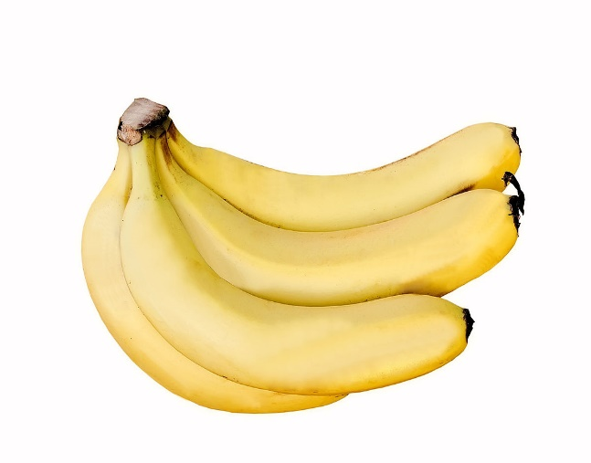

1. **Orange**

• Description: Oranges are rich in vitamin C and provide hydration. They can be eaten fresh or juice.

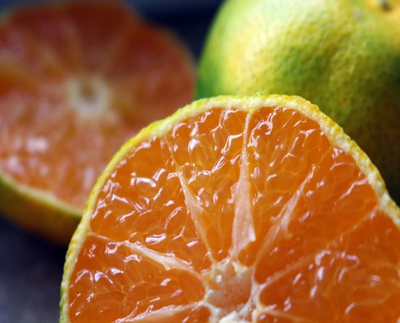

1. **Mango**

• Description: Known as the "king of fruits," mangoes are sweet and juicy, packed with vitamins A and C.

